5TH UNIT
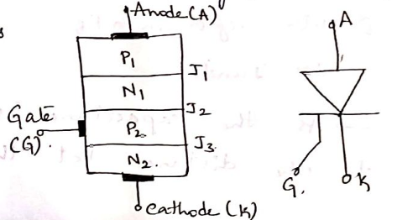
SCR:-
- SILICON CONTROLLED RECTIFIER.
- IS A FOUR LAYER , 3 TERMINAL DIODE.
- THE END OF P ACTS AS ANODE(A).
- THE END OF N ACTS AS CATHODE(K).
- THE P LAYER NEAR TO THE CATHODE ACTS AS A GATE.
- THE SCR IS MADE OF SILICON AS IT HAS LESS LEKAGE CURRENT COMPARED TO GERMANIUM.
CHARACTERISTICS:-
- SCR ACTS AS A SWITCH WHEN IS IN F.B.
- WHEN THE GATE IS OPEN IG=0, THE SCR IS SIMILAR TO THE PNPN DIODE.
- WHEN IG<0, THE AMOUNT OF RB APPLIED TO J2 IS INCREASED BY WHICH THE VOLTAGE BREAKDOWN VBO IS ALSO INCREASED.
- WHEN IG>0, THE AMOUNT OF RB APPLIED TO J2 IS DECREASED , THE VBO IS ALSO DECREASED.
- SO THE BREAKDOWN MAY OCCUR AT LOW VOLTAGE WITH LARGE +VE GATE CURRENT.
- IN VOLTAGE, WHEN SCR IS ‘ON’ IT CAN BE CONTROLLED BY VARRYING THE GATE CURRENT IG. THISIS CALLED “CONTROLLED SWITCH”.
- ONE THE SCR IS ‘ON’ THE GATE LOSSES IT’S CONTROL AND THE GATE CAN NOT BE USED TO SWITCH OFF THE DEVICE.
- TO SWITCH OFF THE DEVICE WE NEED TO DECREASE THE “ANODE CURRENT”BELOW “IH”.
DECREASE THE “VOLTAGE SUPPLY”BELOW “VH”.
- AND KEEP THE AGTE OPEN.
- 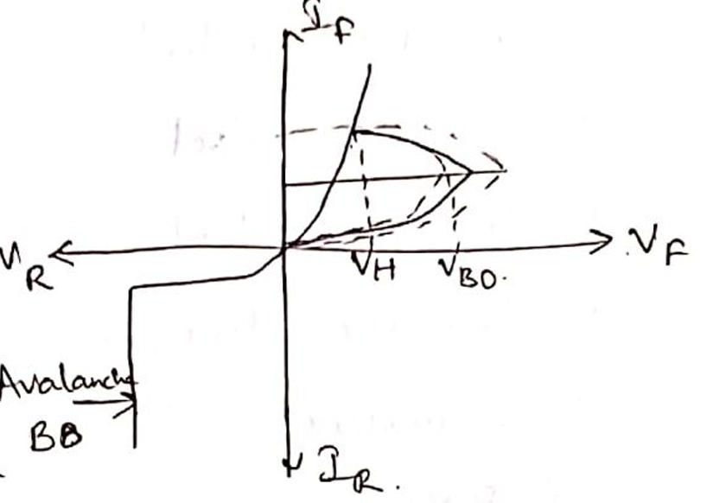
APPLICATIONS:-
- PHASE CONTROL.
- MOTOR CONTROL.
- HEATER CONTROL.
- BATTERY CHARGER.

VARACTOR DIODE:-
- IS ALSO KNOW AS VARICAP.
- IS A TUNING OR VOLTAGE VARIABLE CAPACITOR DIODE.
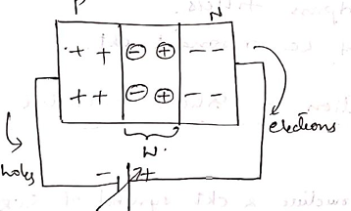
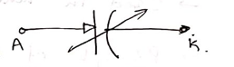
- IT IS A JUNCTION DIODE WITH A SMALL IMPURITY WHICH HELPS TO GET VARIED ELECTRICALLY.

- IF THE RB VOLTAGE IS LARGE THE THE WIDTH OF THE DIPLETION LAYER ‘W’ IS WIDER
- IF THE RB VOLTAGE IS DECREASED THEN THE DEPLETION LAYER ‘W’ IS NARROW.
- THE DEPLETION REGION ACTS AS AN INSULATOR WHICH PREVENTS CONDUCTION BTW P AND N REFION IN THE DIODE( SAME AS DIELECTRIC IT SEPERATES 2 PLATES OF CAPACITOR)
- CAPACITANCE IS INVERSLY PROPOTIONAL TO DIST BTW THE PLATES 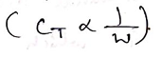
- INCREASE IN RB VOLTAGE RESULTS TO INCREASEIN DEPLETION LAYER.
AND DECREASE IN TRANSITION CAPACITOR(CT).
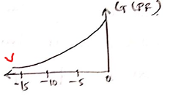
- AT 0 VOLTS THE DEPLTION REGION ‘W’ IS SMALL,
CAPACITANCE LARGE (600PF).
- WHEN RB VOLTAGE IS 15V
- THE CAPACITANCE IS 30PF.

TUNNEL DIODE:-
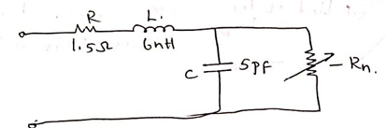
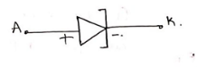
- ESAKI DIODE
- -VE RESISTANCE REGION.
- IS A HEAVILY DOPED DIODE.
- DIFF BTW TUNNEL AND PN DIODE IS DOPING CONCENTRATION.
- NORMAL DIODE:- IS ONE OF 10 POWER 8.
- FOR TUNNEL:- ONE OF THOUSANDS OR HUNDRDS.
- THE DEPLETION REGION WIDTH DECREASES TO MIN VALUE.
- 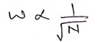 WHERE N IS CONC OF IMPURITY ATOM
- TO MOVE FROM ONE SIDE TO ANOTHER SIDE OF BARRIER THE PARTICLE SHLD HAVE ENERGY EQUAL TO HEIGHT OF POTENTIAL BARRIER.
- IF BARRIER HAVE MIN WIDTH THEN THEIR MIGHT BE A POSSIBILIY OF AN E TO GO THROUGH THE BARRIER
- THIS IS CALLED TUNNELING OF E.
- IS CALLED TUNNEL DIODE.
TUNNELING EFFECT:-
- DEPLETON REGION SHOULD BE SMALL
- AND THE DIODE SHOULD BE HEAVILY DOPED.
- OVERLAP MAY OCCUR BTW VB ON P SIDE AND CB ON N SIDE.
- THE C.B E MOVE THROUGH TUNNEL TO P SIDE UNDER F.B CONDITION
IN REVERSE BIAS:-
- WHEN RB APPLIED:-HEIGHT OF THE BARRIER IS INCREASED
- THE N SIDE ENERGY STATE SHLD SHIFT TO DOWNWARDS OF P SIDE
- POTENTIAL BARRIER IS INCREASED.
- THEN THE E WILL FLOW FROM P SIDE TO N SIDE .
- BEHAVIOUR OF THE TUNNEL IS SAME AS NORMAL PN DIODE.
IN REVERSE BIAS:-
- FORWARD VOLTAGE APPLIED THE POTENTIAL BARRIER DECREASES.
- THE N SIDE ENERGY STATE SHLD SHIFT UOWARDS OF P SIDE.
- THE E WILL TUNNEL FROM N SIDE TO P SIDE GIVING RISE IN FORWARD CURRENT.
AS FORWARD VOLTAGE IS INCREASED MORE AND MORE E WILL TUNNEL FROM N TO P SIDE GIVING RISE IN FORWARD CURRENT.
IF FORWARD VOLTAGE IS STILL INCREASING THE NO OF OCCUPIED STATES WILL BE REDUCED.
THE TUNNELING WILL STOP WHEN THE CURRENT REACHES TO ZERO.
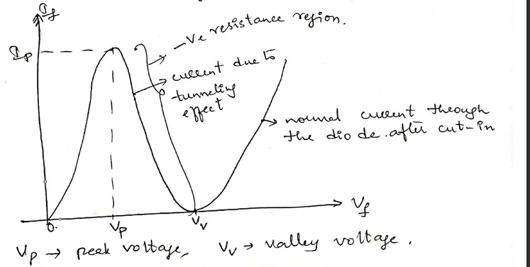
ENERGY DIAGRAM OF TUNNEL DIODE:-
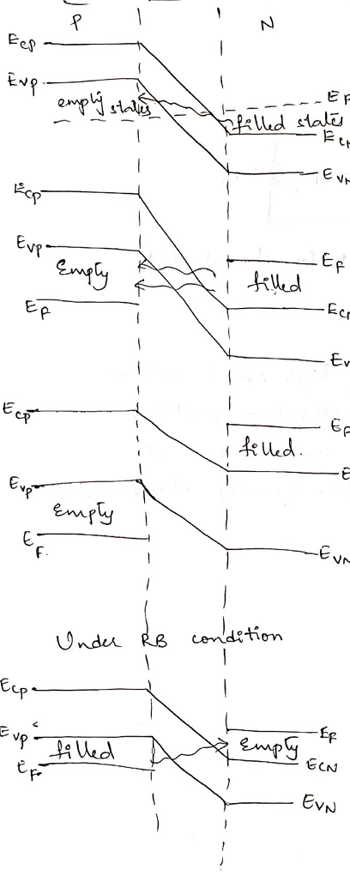
APPLICATIONS:-
- IN HIGH SPPED SWITCH.
- RELAXATION OSCILLATOR
- MICROWAVE OSCILLATOR

ZENER DIODE:-
- MELVIN ZENER IN 1915
- IS A SEMICONDUCTOR MATERIAL OR DEVICE
- IS HEAVILY DOPED
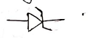
- SYMBOL:-
- WHEN RB VOLTAGE INCREASE BREAK DOWN OCCURS.
- CURRENT AND POWER THROUGH THE JUNCTION WILL BE HIGH.
- IN FB :- THE ZENER DIODE ACTS AS PN DIODE.
- IN RB:- THE BREAKDOWN OF JUNCTION OCCURS( BREAKDOWN DEPENDS ON THE AMT OF DOPING)
- HEAVYILY DOPED | - LIGHTLY DOPED
- DEPLETION LAYER IS THIN | - HAS HIGH BREAKDOWN VOLTAGE
- BREAKDOWN AT:- LOWER REVERSE VOLTAGE
- BREAKDOWN VOLTAGE IS SELECTED BASED ON DOPING.
- THE INCREASE IN CURRENT UNDER RB IS DUE TO
1.AVALANCHE BREAKDOWN
2.ZENER BREAKDOWN.
AVALANCHE BREAKDOWN:-
- RB INCREASE, FIELD IN JUNCTIONT INCREASE
- THE CARRIERS WHILE TRAVELLING OBTAIN HIGH AMT OF KE FROM FIELD.
- BY WHICH THE V OF CARRIES INCREASE.
- E COLLIDE WITH COVALENT BONDS AND CREATE E-HOLE PARIS.
- HAPPENDS AGAIN AND AGAIN.
- IS A CUMMILATIVE PROCESS
- RESULTS IN GENERATION OF AVALANCHE CHARGE CARRIERS
- THIS HAPPENS IN SHORT TIME.
- OCCURS AT HIGHER BREAKDOWN VOLTAGE
- THIS CARRIES GENERATION IS KNOWN AS AVALANCHE BREAKDOWN
ZENER BREAKDOWN :-
- AS P AND N HIGHLY DOPED.
- DEPLETION LAYER WIDTH IS SMALL
- FIELD IN DL BECOMES HIGH IF THE APPLIED V IS 6V OR LESS.
- OCCURS FOR LOWER BREAKDOWN VOLTAGE
- SUCH DIODES ARE CALLED ZENER DIODES.
AS VOLTAGE REGULATOR:-
- HEPLS CONTROL VOLTAGE
ALLOWS THE CURRENT TO FLOW BACKWARDS WHEN V REACH CRETAIN LEVEL
- KEPPS V STABLE IN TERMINALS( 5.1 VOLTS)
- MAINTAINS VOLTAGE EVEN IF THE CIRCUITS NEEDS MORE POWER.
- USED FOR LOW POWER GADGETS.

LED:-
- IS AN OPTICAL SEMICONDUCTOR DEVICE.
- WIDELY USED SEICONDUCTOR AMONG ALL OTHER DIODES
- EMITS EITHER VISIBLE OR INVISIBLE INFRARED LIGHT IN FB.
- LEDS THAT EMIT INVISIBLE INFRARED LIGHT ARE USED FOR REMOTE CONTROLS.
- EMITS LIGHT WHEN VOLTAGE APPLIED
IN FB:-
- THE FREE E IN CB RECOMBINE WITH HOLES IN VB AND RELEASE ENERGY IN LIGHT FORM.
- AVAILABLE IN MANY COLORS LIKE YELLOW ORANGE RED GREEN ETC
WORKING:-
- WORKS ONLY IN FB
- WHEN IN FB THE FREE E FROM N SIDE AND HOLES FROM P SIDE ARE PUSHED TOWARDS JUNCTION.
- WHEN REACHED THE JUNCTION OR DEPLETION REGION
- THE E AND RECOMBINE WITH HOLE IN +VE IONS.
- SIMILLARLY THE HOLE FROM P AND E RECOMBINE IN THE DEPLETION REGION.
- CUZ OF RECOMBINTAION THE WIDTH OF DEPLETION REGIO DECRESES.
- AND MORE CHARGE CARRIED WILL CROSS PN JUNCTION
- SOME CHARGE CARRIES WILL CROSS PN BEFORE RECOMINATION IN DP REGION.
- THE RECOMBINATION TAKES PLACE IN DEPLETION REGION AS WELL AS IN P AND N TYEP SEMICONDUCTR.
- THE FREE E IN CB RELEASE ENERGY IN FORM OF LIGHT .
APPLICATIONS:-
- CALCULATORS
- PICTURE PHONES
- TRAFFIC SIGNALS
- COMPUTERS
- MIRCO PROCESSORS
- WATCHES
- MULTIMETERS
- AUTOMOTIVE HEAT LAMPS
- CEMERA FLASHES

